Eda İslam 2585081 | Yağmur Can 2637536
EXPERIMENT II ANALYSIS OF SIMPLE ELECTRICAL CIRCUITS USING KIRCHHOFF’s and OHM’s LAWS
EQUIPMENT LIST:
Power Supply
Digital Oscilloscope
Function\Arbitrary Waveform Generator
Resistors (100Ω, 6 x 1kΩ, 3.3kΩ, 2 x 1.2kΩ, 6.8kΩ, 10k pot).
PRELIMINARY WORK:
QUESTION 1
A)
- Using the available components in the equipmant list we can obtain 7.8 kΩ by:
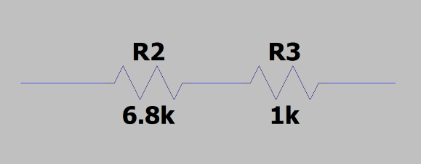
- We can take 6.8 kΩ resistor and 1 kΩ resistor and connect them in series.

- We can take 1.2 kΩ, 1.2 kΩ, 3.3 kΩ, 1 kΩ, 1 kΩ and 100 Ω and connect them in series to obtain 7.8 kΩ.
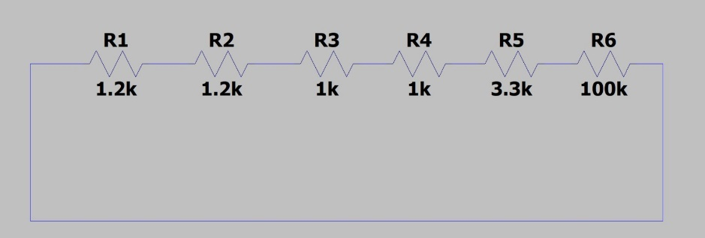

- V=I*RI=V/R
I=Vin(t)/(7.8+3.3)=Vin(t)/11.1
Vab(t)=I*7,8
Vab(t)=Vin(t)*7,8/11.1=Vin(t)*0,702
B)
a) Since 7.8 and 5 kΩ are parallel their equivalent resistance is:
1/Req=1/R1 +1/R2 which in this case: 1/Req= 1/7.8 +1/5 = 12.8/39 so the equivalent between node a and b is; Rab= 3,046. In total equivalence, they are in series with the 3.3 kΩ resistor so it will be 3.3+3.05=6.35.
- V=I*R
Vin(t)=I*6.35
Vab(t)=Vin(t)-[3.3*Vin(t)/6.35]=0.48Vin(t)
Ia(t)=(7.8/12.8)*(Vin/6.35)=0.096
- Vab(t)=Vin(t)-(3.3*Vin(t)/6.35) =0.48Vin(t)

C) No, we can not use voltage divider circuit of Figure 2.1 as a voltage source to deliver power to a load connected between nodes a and b. Because, 3.3ohm resistor uses bigger percentage of the voltage in the circuit.

QUESTION 2
- The frequency of the sinusoidal voltage signal is 50 Hertz.

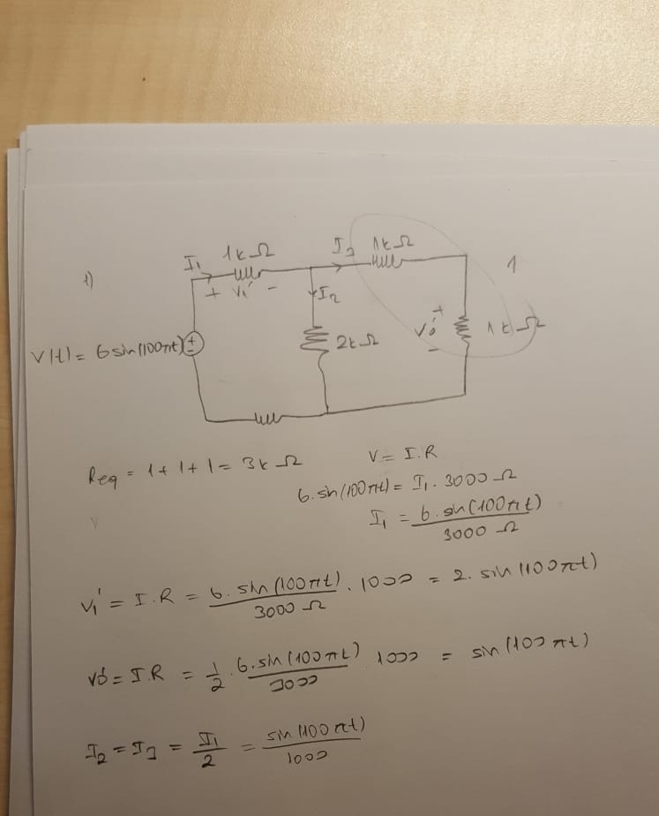

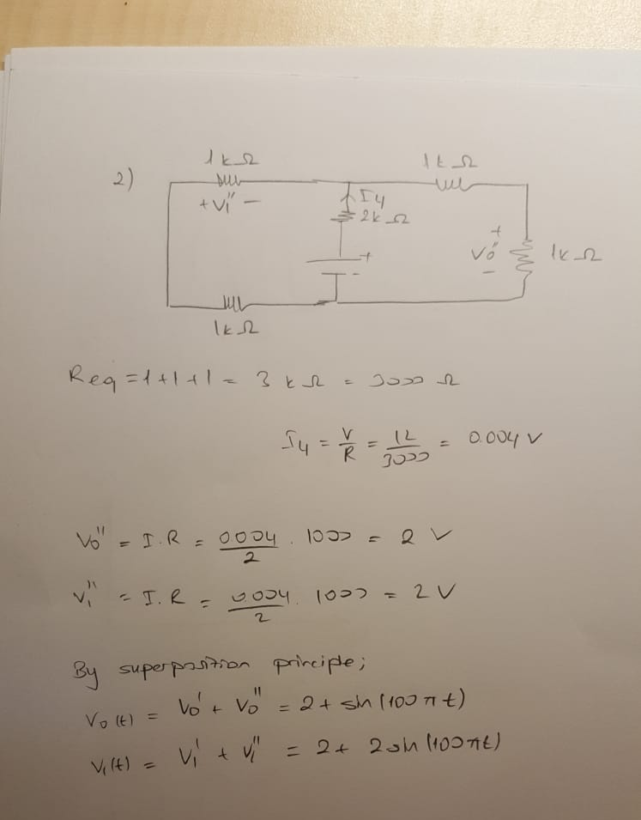

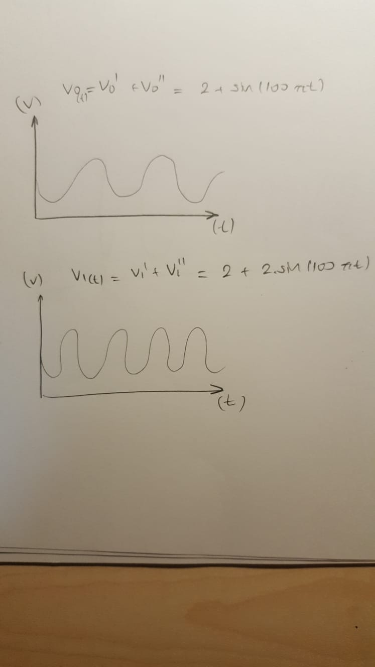

- In our calculations we find:
V0(t)= 2+sin(100πt)
V1(t)=2sin(100πt)+2
We predicted that the difference is sin(100πt), so the graph should be fluctuating in the waveform of sin(100πt). Also what we calculated using LTSpice corrected our assumptions.
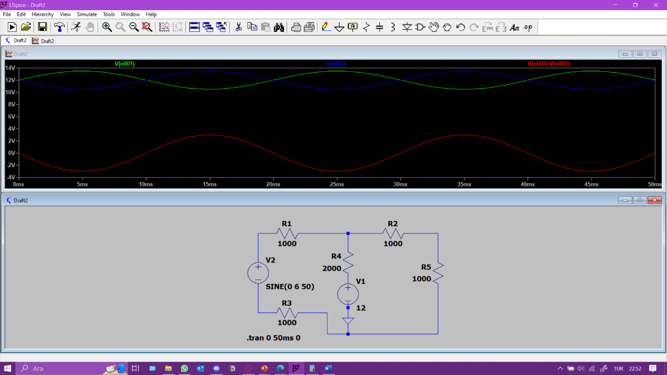

QUESTION 3
- I1=I3, Ix=I4 and since Vbc=0V when bridge balanced ID=0 A, so the relationship between the resistors are:
R3*İ3=R4*I4 and R1*I1=Rx*Ix
By changing the places of the variables: R1/R3=Rx/R4 therefore Rx= (R1/R3) * R4
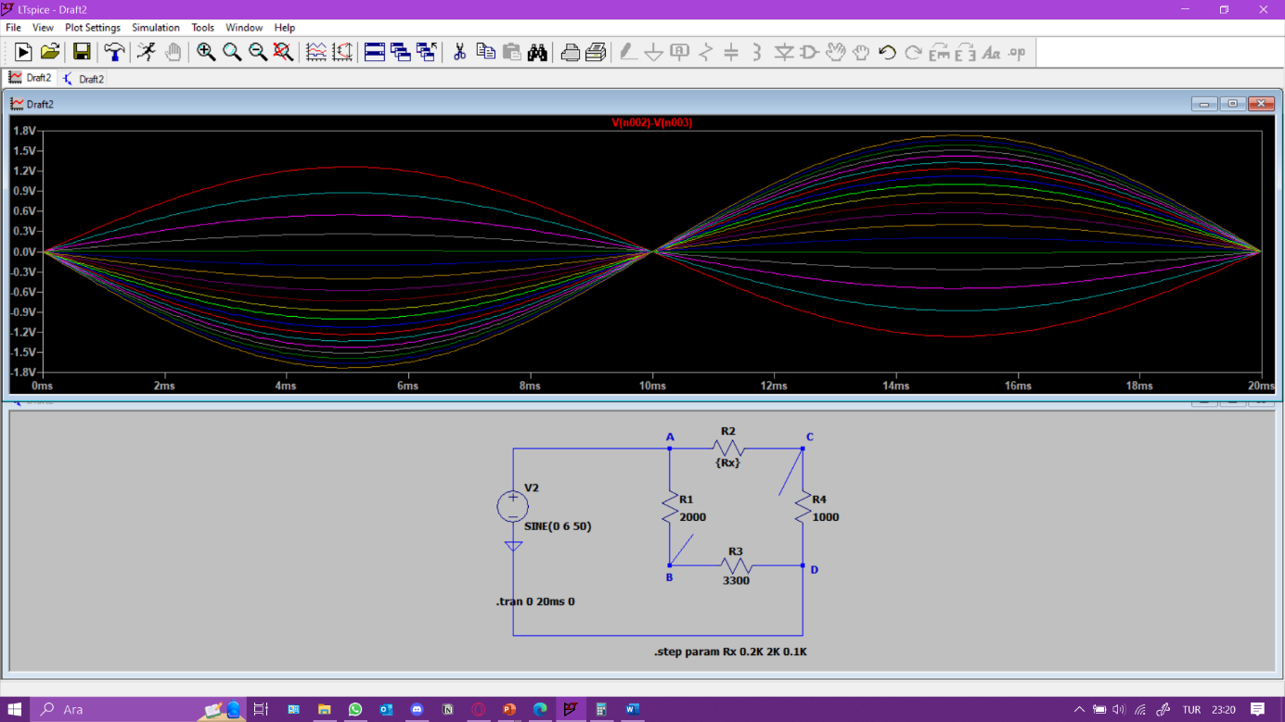
- By the formula in (a) Rx=0.60 kΩ with the given values of resistors. When the Rx=0.60 kΩ the voltage is 0 between the nods b and c (the bridge is balanced). This proves that the calculations are true.

